SMART TECHNICIAN ASSIGNING
A Project Report for Industrial Training and Internship
submitted by

SHANKAR KUMAR DHAR

In the partial fulfillment of the award of the degree of

BCA
in the
CSE

Of

JIS UNIVERSITY


Ardent Computech Pvt. Ltd.


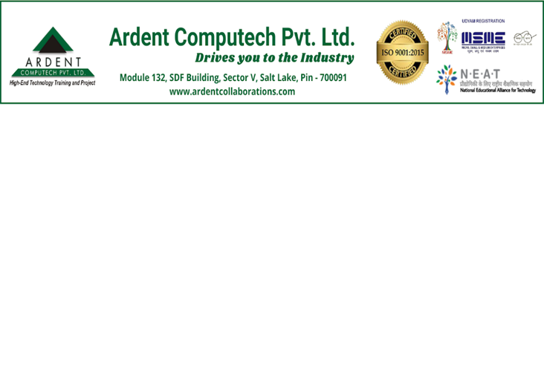
CERTIFICATE FROM SUPERVISOR
This is to certify that Shankar Kumar Dhar, 23CS2061135 have completed the project titled Smart Technician Assigning under my supervision during the period from 16/06/2025 to 05/07/2025 which is in partial fulfillment of requirements for the award of the BCA degree and submitted to the Department of BCA(CSE) of JIS University.

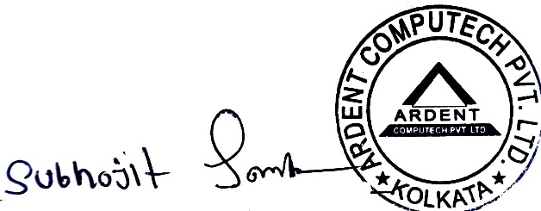

___________________________
Signature of the Supervisor

Date: 10/07/2025

Name of the Project Supervisor: Subhojit Santra


BONAFIDE CERTIFICATE
Certified that this project work was carried out under my supervision
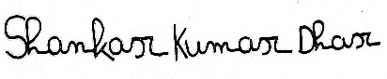
Smart Technician Assigning is the bonafide work of
Name of the student: Shankar Kumar Dhar Signature:

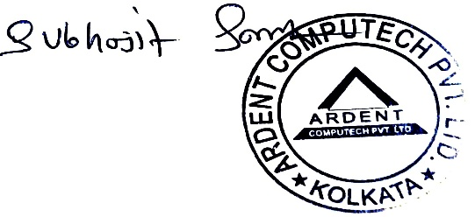
SIGNATURE
Name:

PROJECT MENTOR: Subhojit Santra

SIGNATURE
Name:
EXAMINERS
Ardent Original Seal


ACKNOWLEDGEMENT

The achievement that is associated with the successful completion of any task would be incomplete without mentioning the names of those people whose endless cooperation made it possible. Their constant guidance and encouragement made all our efforts successful.

We take this opportunity to express our deep gratitude towards our project mentor, Subhojit Santra for giving such valuable suggestions, guidance and encouragement during the development of this project work.

Last but not the least we are grateful to all the faculty members of Ardent Computech Pvt. Ltd. for their support.

